**Grade Assignment 4**

**Employee Management**

**Group Id**

2A-S8

**Group Member**

Reetam Ghosh

Swagata Mukherjee

Daniel Rajasekar

Nitin Mohan Shivale

**Application**

Spring Boot (Eclipse IDE)

MySQL Database

Postman API & Swagger UI

**MySQL**

Creating roles in the database dynamically by MySQL:

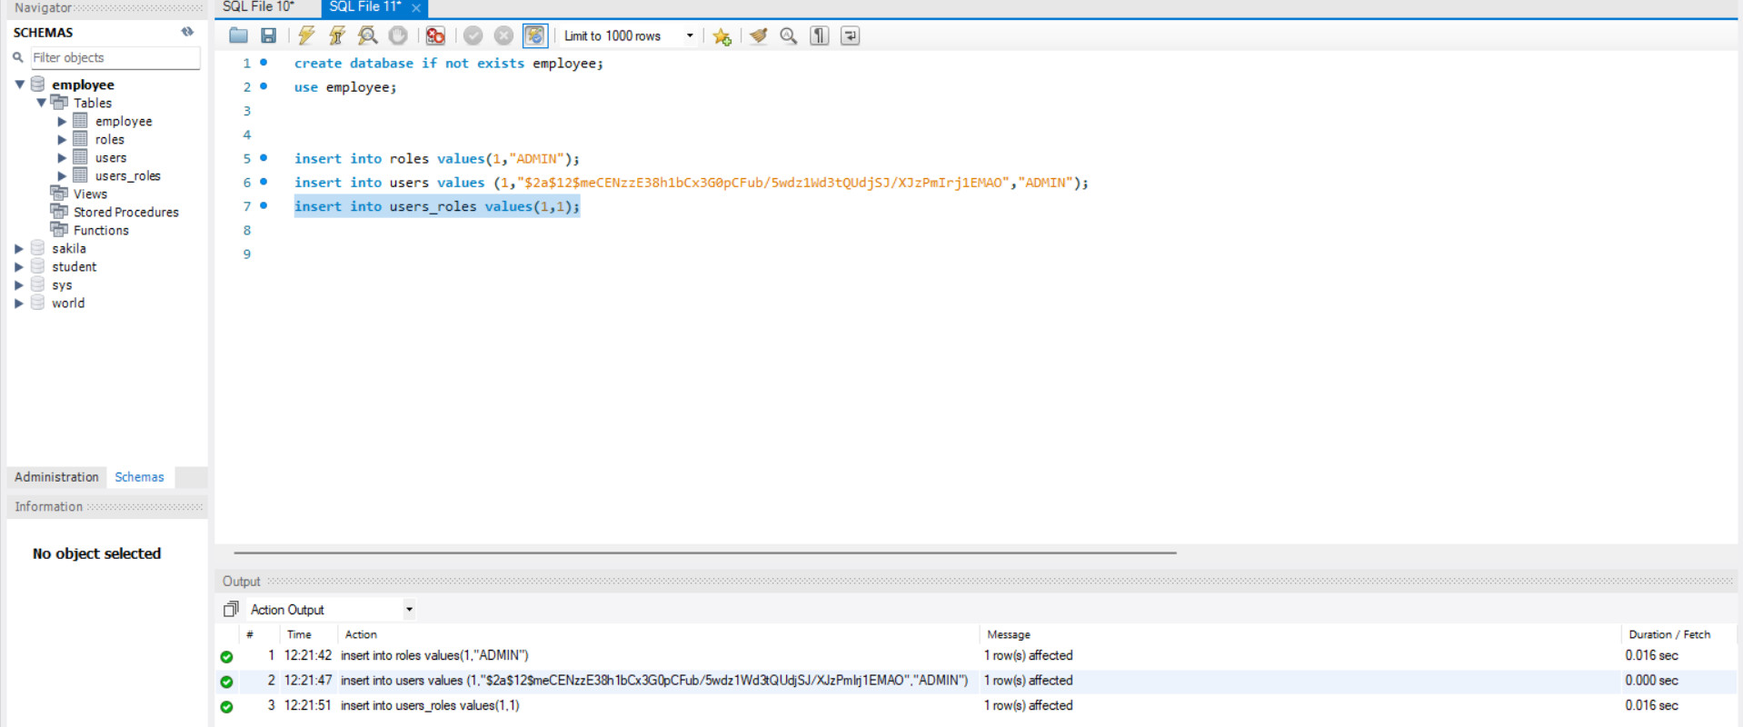

Implementing the database data into login page:

Url (“localhost:8080/”)

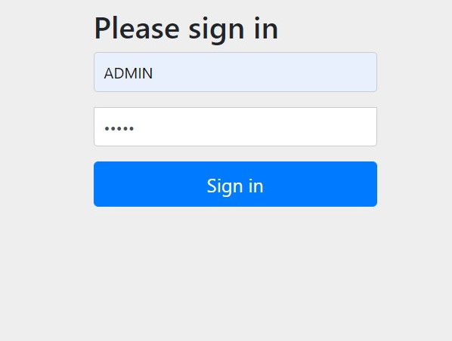

After Signed In Web page navigate to Home Page and click the link give bellow…

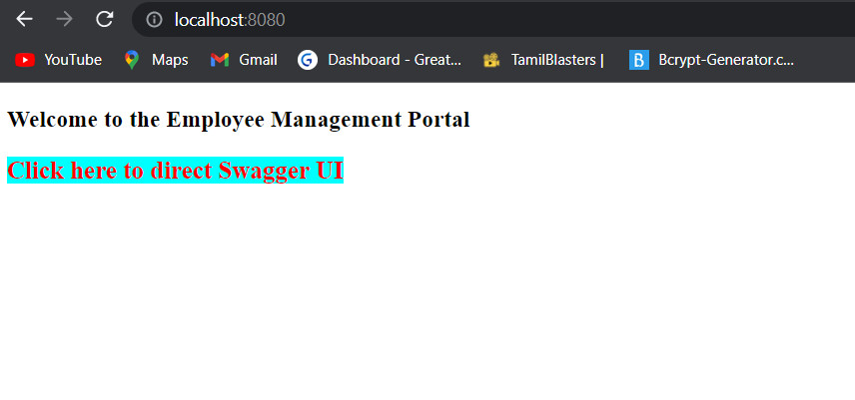

This link direct the web page to swagger UI

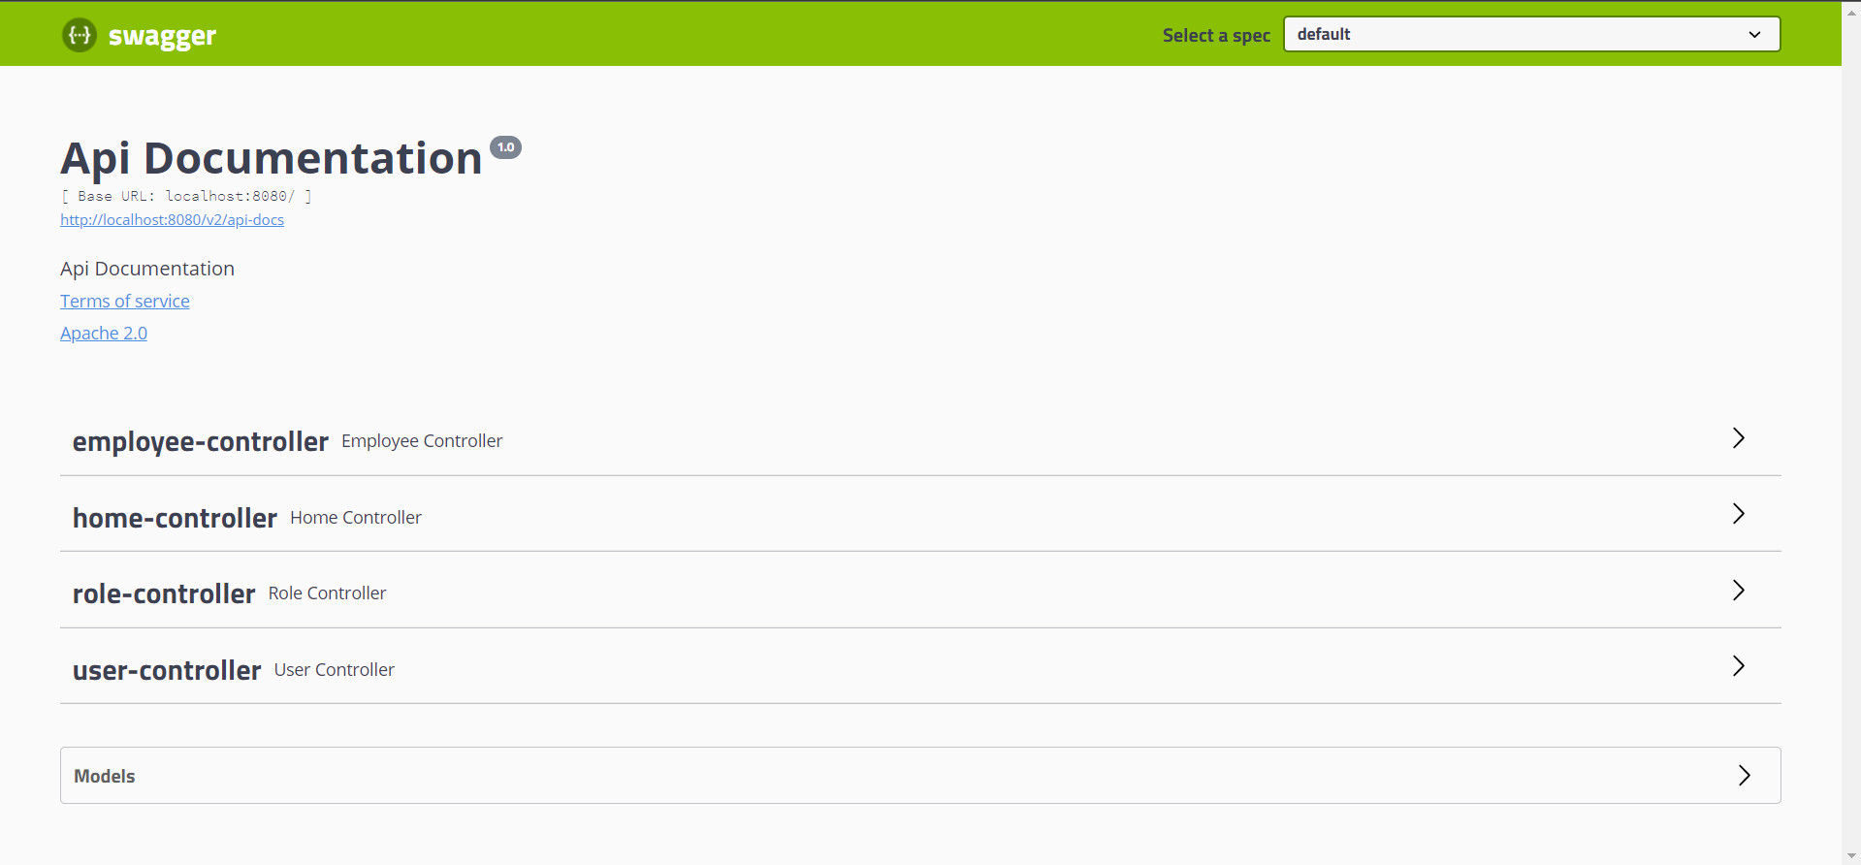

Add users in the DB through web application.

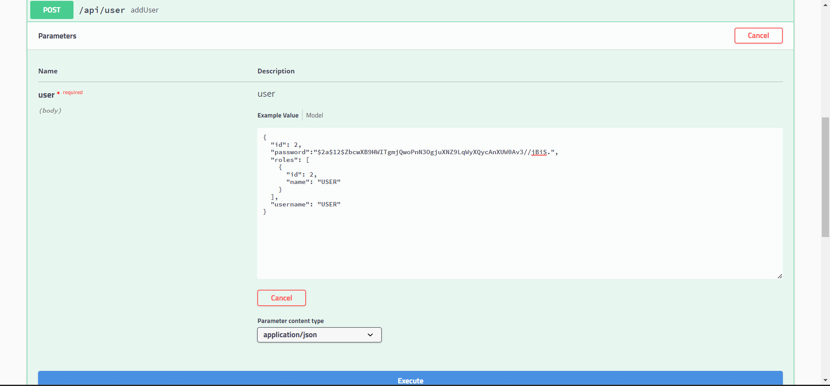

User created successfully.

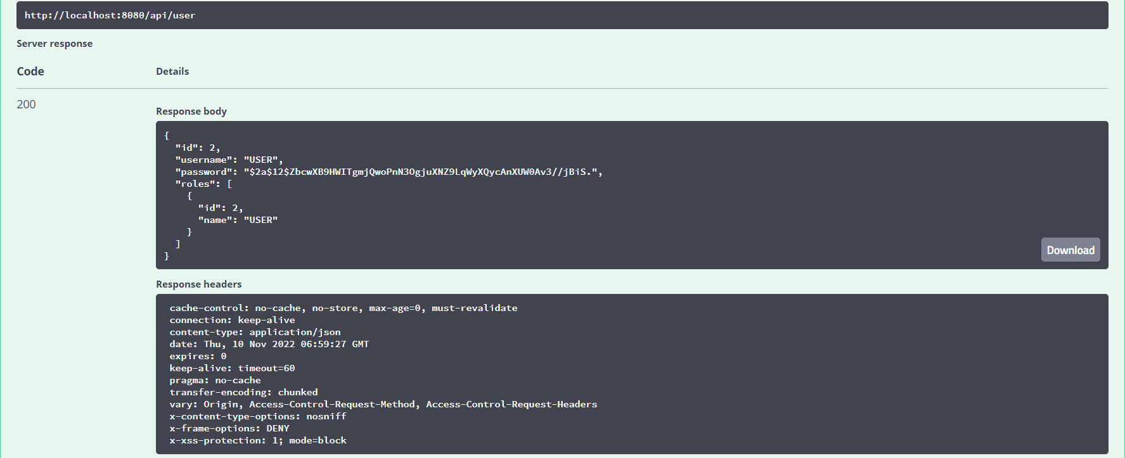

View the users in database MySQL

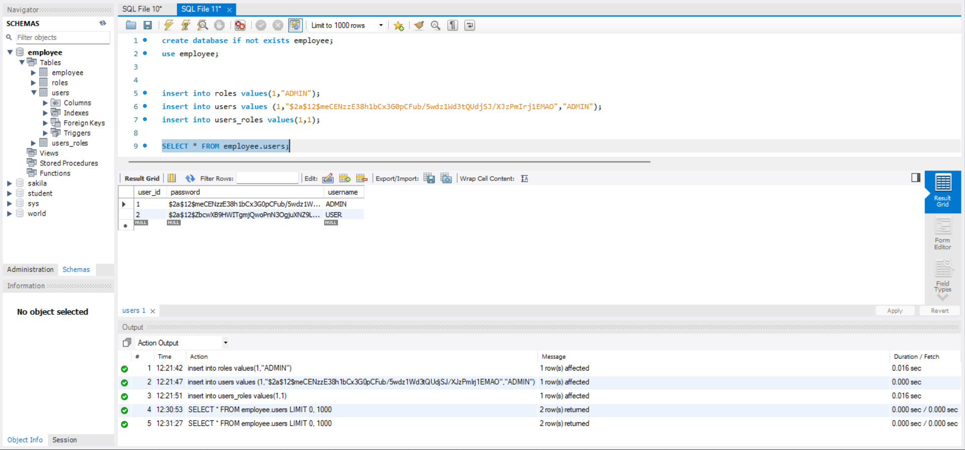

Employee Details before adding:

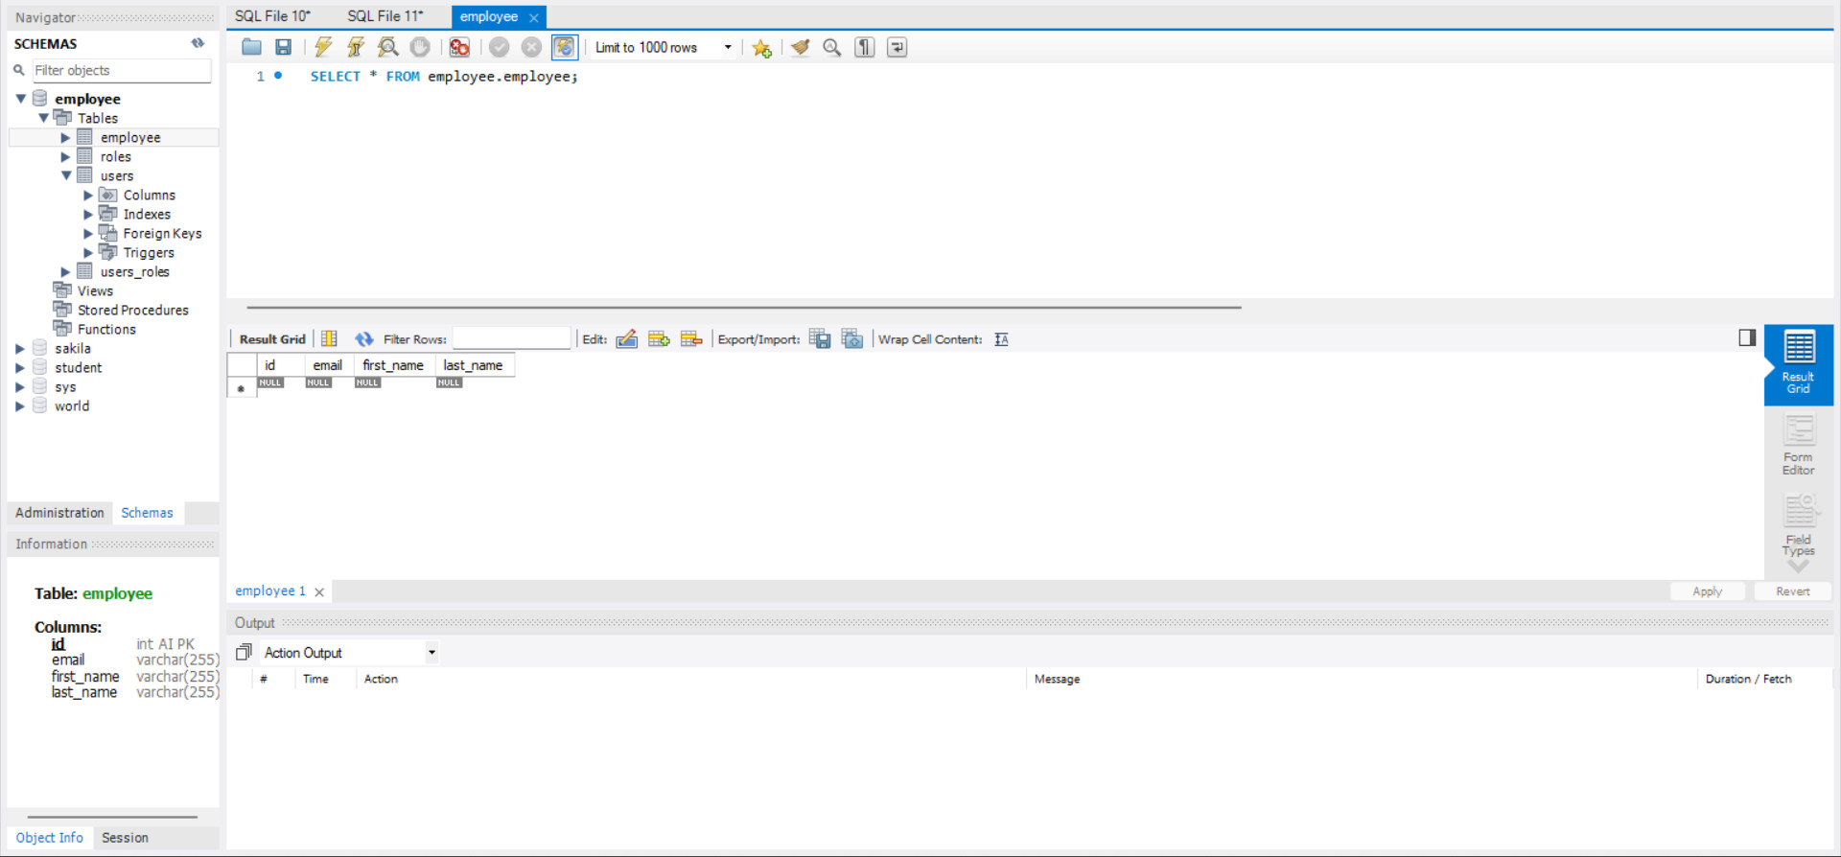

CRUD Operation:

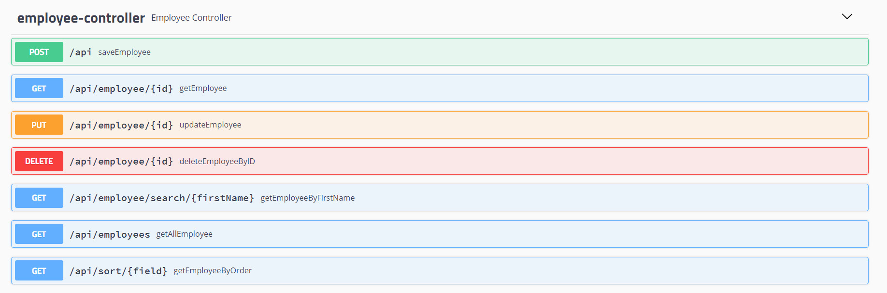

Adding Employee Details (POST Method):

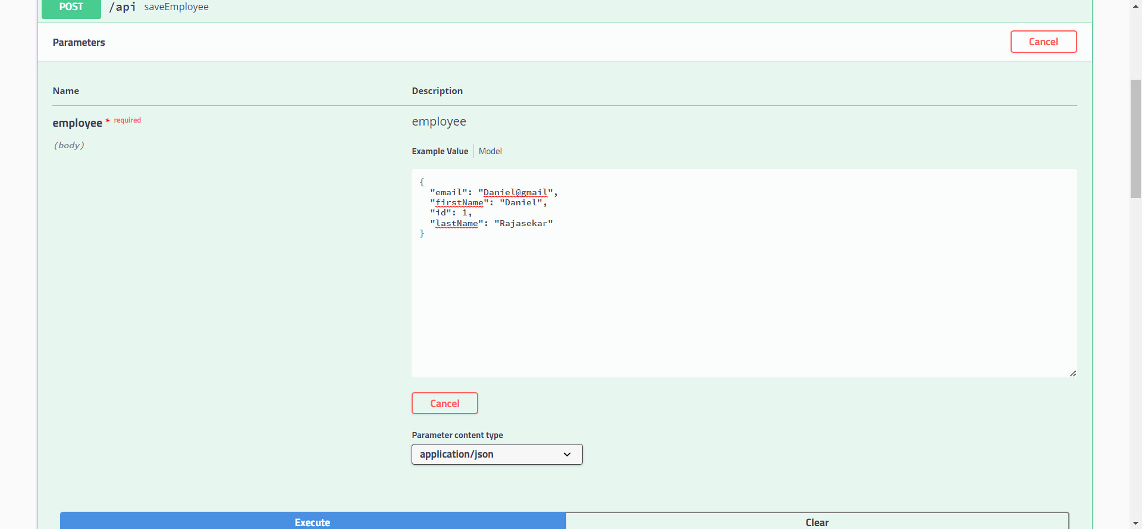

Employee Created Successfully:

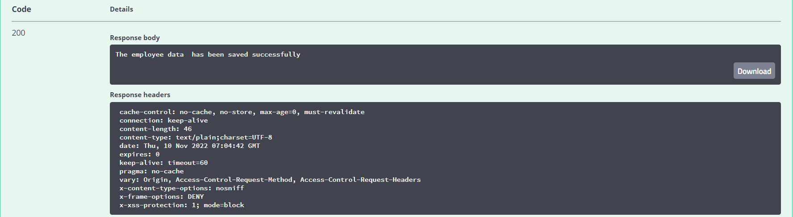

Get All Employees (GET method):

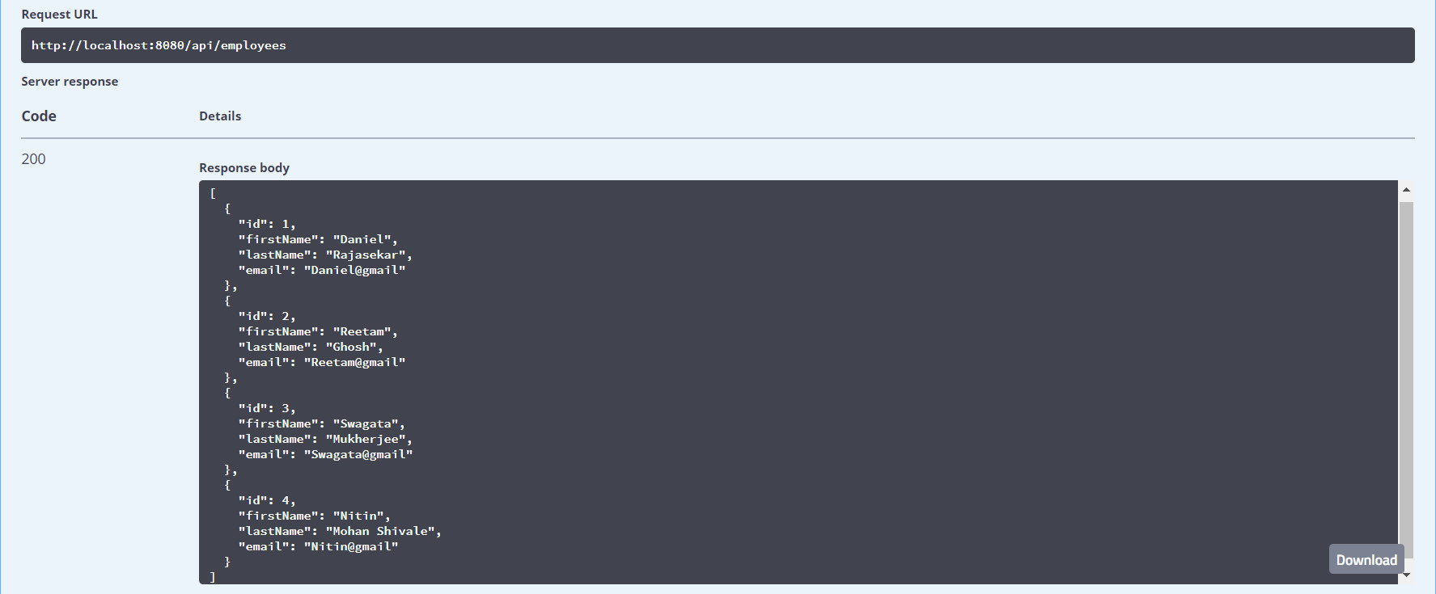

Get employee by Id(GET Method):

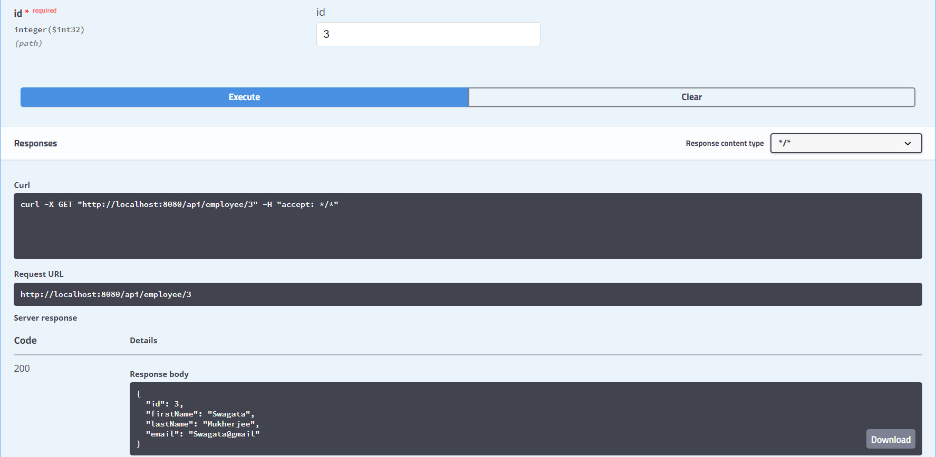

Update Employee(PUT Method):

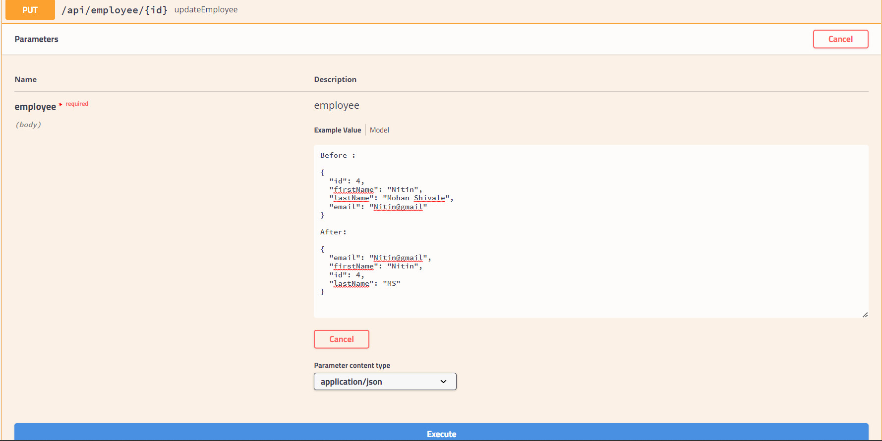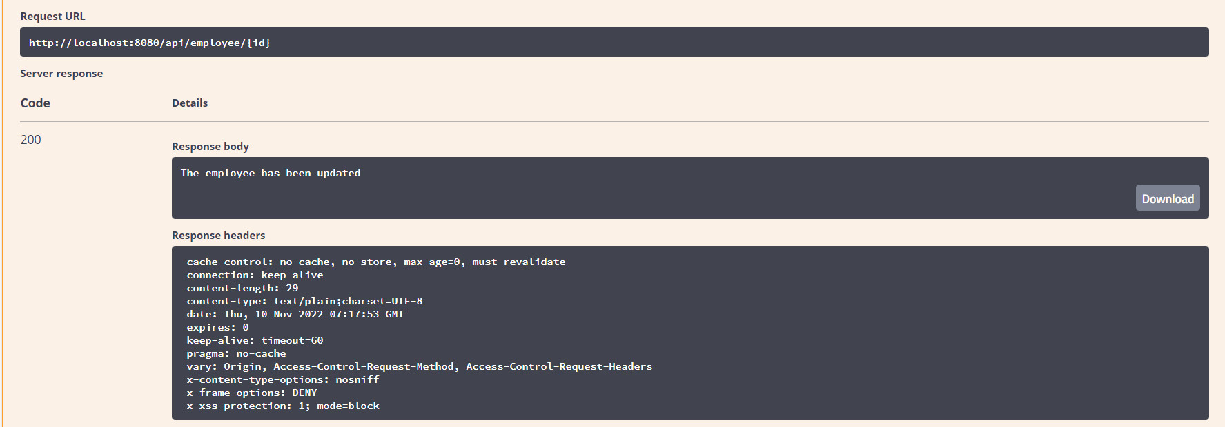

Delete By Id(DELETE Method):

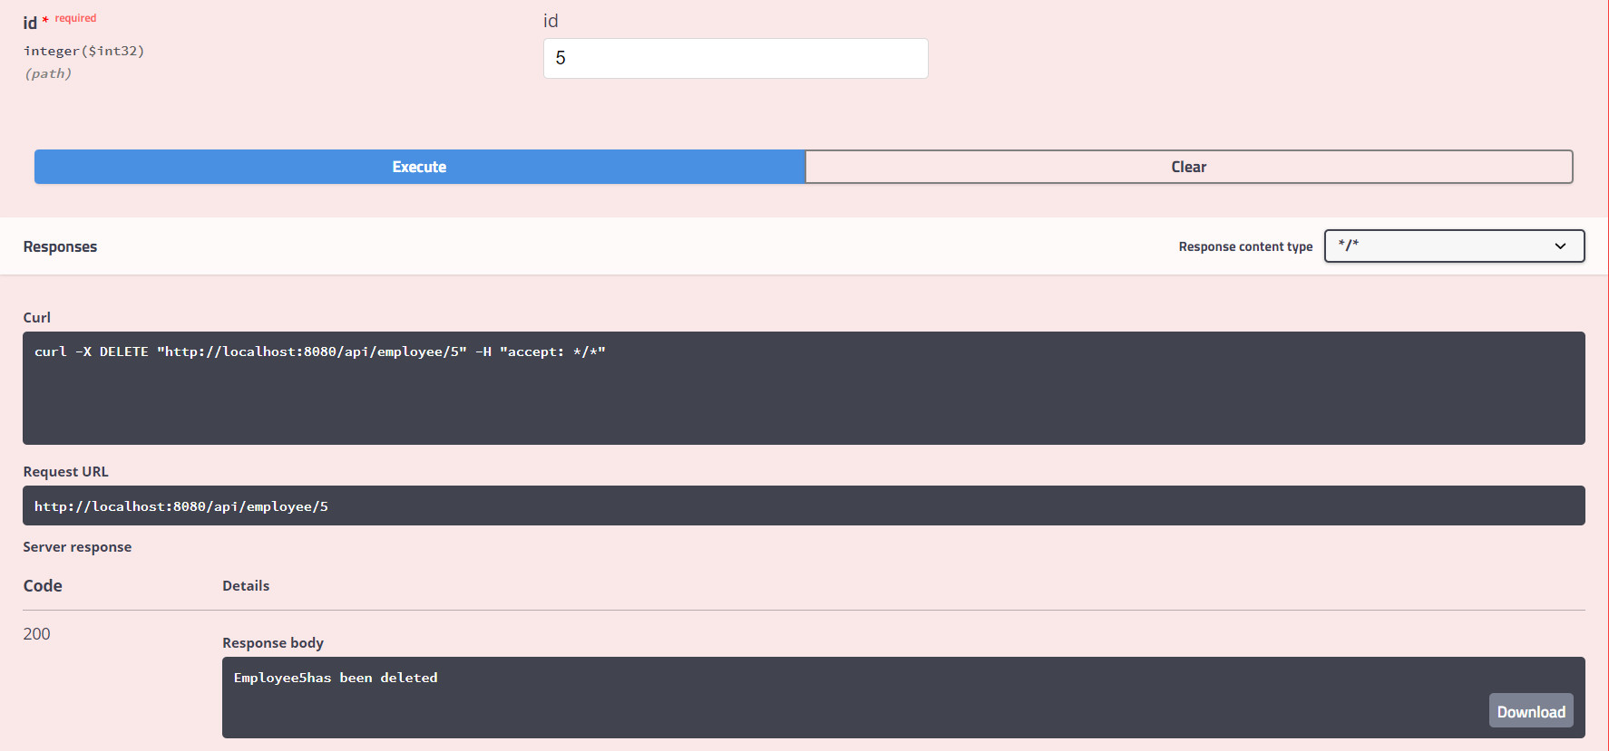

Get Employee By FirstName(GET Method):

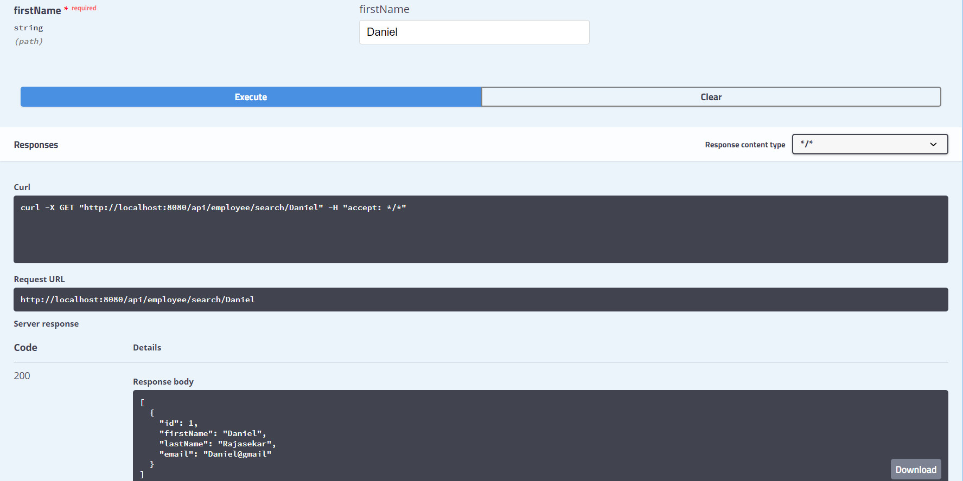

Get Employee By ASC Order(GET Method):

